MARION CITY BOARD OF ZONING APPEALS
VARIANCE REQUEST
STAFF REPORT
April 6, 2021

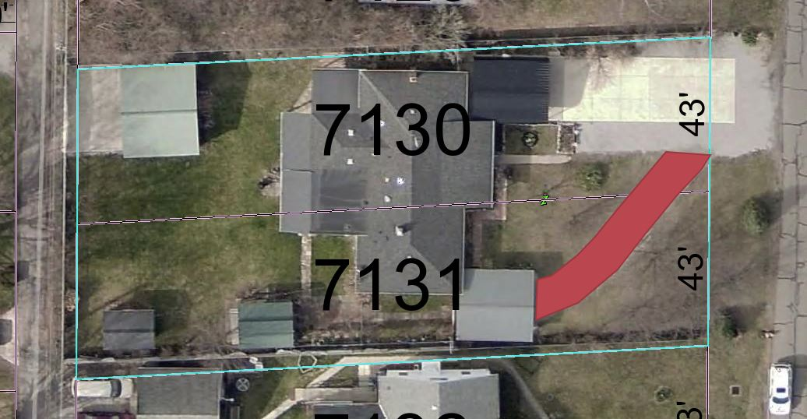

APPLICANT: Odessa Myers

LOCATION: 487 Forest Lawn Boulevard

ZONING: “R-1A" - Single-Family District, Low Density

REQUEST: Variance from Section 1153.034 (B) (1) which requires that driveways not exceed 30% of the front yard area if they are not straight. The proposal is to add an additional angled concreate front driveway that would exceed this amount.

BACKGROUND: The applicant states they have been using a gravel driveway since they bought the property in 1999 and would like to turn that driveway into a concreate driveway with the dimensions of 10’ by 75’.

COMMENTS: The applicant has a concreate driveway in their backyard off of an alley.

IN FAVOR OF THIS REQUEST:

1. The applicant states they are 75 years old and finds that backing into the street is difficult.

AGAINST THIS REQUEST:

1. The applicant already has a front yard driveway that complies with the current regulations that appears to be closer to their house.

2. The applicant also has a concreate driveway in the backyard of their house.

3. The applicant’s request for a third concreate driveway appears to be excessive and would exceed the 30% front yard driveway requirement.

4. The applicant could add a T turnaround to their driveway.

STAFF RECOMMENDATION: Given that the applicant has a conforming driveway it would not further the goals of the zoning code to add a non-conforming driveway.

